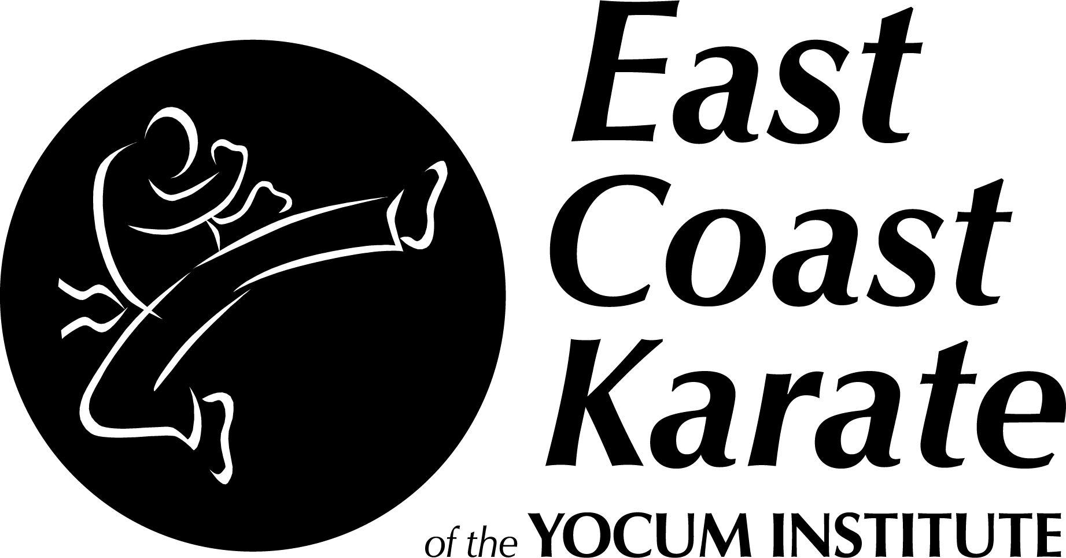
3000 Penn Avenue
West Lawn, PA 19609
610-376-1576

TRAINING OATH

I will.... Develop myself in a positive manner and
avoid anything that could reduce my mental
growth or physical health.

I will.... Develop self discipline in order to bring out
the best in myself and others.

I will.... Use what I learn in class constructively and
defensively; to help myself and my fellow
man and never to be abusive or offensive.

THIS IS A BLACK BELT SCHOOL
WE ARE DEDICATED
WE ARE MOTIVATED
WE ARE ON A QUEST TO BE OUR BEST!

"OSU"

